***SQL ASSIGNMENT***

QUESTION 1: FIND OUT HOW GOOD MY WEST IS AS COMAPRED TO EAST W.R.T. NUMBER OF PRODUCTS BEING SOLD.

ANSWER 1:

1. FIRST WE WILL FIND THE NUMBER OF PRODUCTS SOLD IN WEST REGION:

**SELECT COUNT([PRODUCT ID]) as CID FROM MD WHERE REGION = 'WEST'**

1. THEN WE WILLFIND THE NUMBER OF PRODUCTS SOLD IN EAST REGION:

**SELECT COUNT([PRODUCT ID]) as CPID FROM MD WHERE REGION = 'EAST'**

1. SINCE THE DIVISION OF TWO INTEGERS VALUES IS INTEGER, I HAVE USED CAST TO CONVERT IT INTO FLOAT DATA TYPE:
2. FINAL ANSWER

**SELECT cast((SELECT COUNT([PRODUCT ID]) as CID FROM MD WHERE REGION = 'WEST') as decimal(7,2))/(SELECT COUNT([PRODUCT ID]) as CPID FROM MD WHERE REGION = 'EAST')**

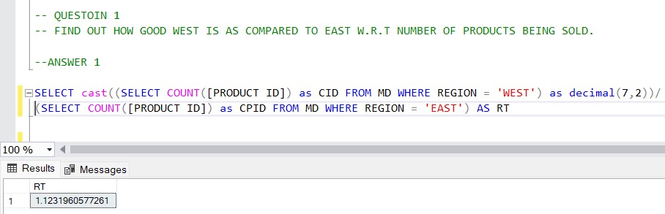

QUESTION 2 : FIND OUT RETENTION RATE

ANSWER 2 :

1. FIRST WE WILL FIND REPEATED CUSTOMERS BY FINDING THE CUSTOMER ID HAVING COUNT OF DISTINCT ORDER ID IS GREATER THAN 1.

**create view repeated_customers as**

**(select [customer id], count(distinct([order id])) as cc from md group by [Customer ID] having count(distinct([order id]))>1)**

1. THEN WE WILL FIND TOTAL NUMBER OF CUSTOMERS.

**select count([customer id]) from Customers**

1. RETENTION RATE = (REPEATED CUSTOMERS/TOTAL CUSTOMERS)*100

**select (((select count(*) from repeated_customers)*1.0)/(select count([customer id]) from Customers))*100 AS RETENTION_RATE**

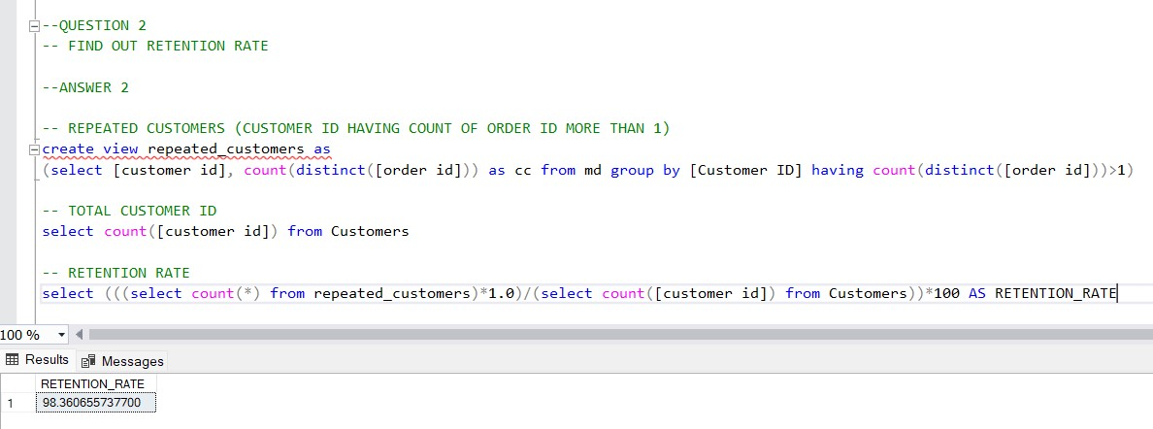

QUESTION 3 : WRITE THE QUERY FOR SHOWING TOP 10 CUSTOMERS AS PER STATE SALES WISE.

ANSWER 3:

1. FIRST WE WILL CALCULATE SUM OF SALES OF EACH CUSTOMER STATE WISE.

**SELECT [CUSTOMER NAME], STATE, SUM(SALES) AS TOTAL_SALES FROM MD GROUP BY STATE,[Customer Name]**

1. THEN WE WILL SIMPLY CALCULATE TOP 10 CUSTOMERS ORDER BY SUM OF SALES.

**SELECT TOP(10) * FROM (SELECT [CUSTOMER NAME], STATE, SUM(SALES) AS TOTAL_SALES FROM MD GROUP BY STATE,[Customer Name] ) AS CUSTOMER_TABLE ORDER BY TOTAL_SALES DESC**

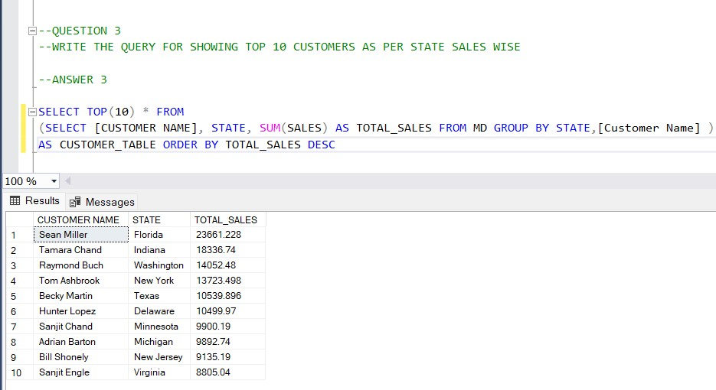

QUESTION 4 : HOW MANY CUSTOMERS HAVE NOT PLACED ORDERS IN THE LAST TWO MONTHS.

ANSWER 4 :

1. FIRST WE WILL CALCULATE LAST DATE AND DATE 2 MONTHS PRIOR LAST DATE BY USING MAX AND DATEADD

**SELECT MAX([Order Date]) FROM MD**

**SELECT DATEADD(MONTH,-2,(SELECT MAX([Order Date]) FROM MD))**

1. THEN WE WILL FIND THE NUMBER OF CUSTOMERS WHO HAVE PLACED ORDERS IN THE LAST TWO MONTHS BY WRITNG QUERY USING SUB QUERY AND BETWEEN.

**SELECT COUNT(*) AS CC FROM**

**(SELECT distinct([Customer ID]) AS CID FROM MD WHERE [ORDER DATE] BETWEEN**

**(SELECT DATEADD(MONTH,-2,(SELECT MAX([Order Date]) FROM MD))) AND (SELECT MAX([Order Date]) FROM MD) GROUP BY [CUSTOMER ID]) AS CID**

1. THEN I HAVE SUBTRACTED ABOVE QUERY FROM TOTAL NUMBER OF CUSTOMERS

(TOTAL NUMBER OF CUSTOMERS – NUMBER OF CUSTOMER WHO HAVE PLACED ORDER IN THE LAST TWO MONTHS)

**select (select count(distinct([customer id])) from md) -**

**(SELECT COUNT(*) AS CC FROM (SELECT distinct([Customer ID]) AS CN FROM MD WHERE [ORDER DATE] BETWEEN**

**(SELECT DATEADD(MONTH,-2,(SELECT MAX([Order Date]) FROM MD))) AND (SELECT MAX([Order Date]) FROM MD) GROUP BY [Customer ID]) AS CN) AS NO_OF_CUSTOMERS**

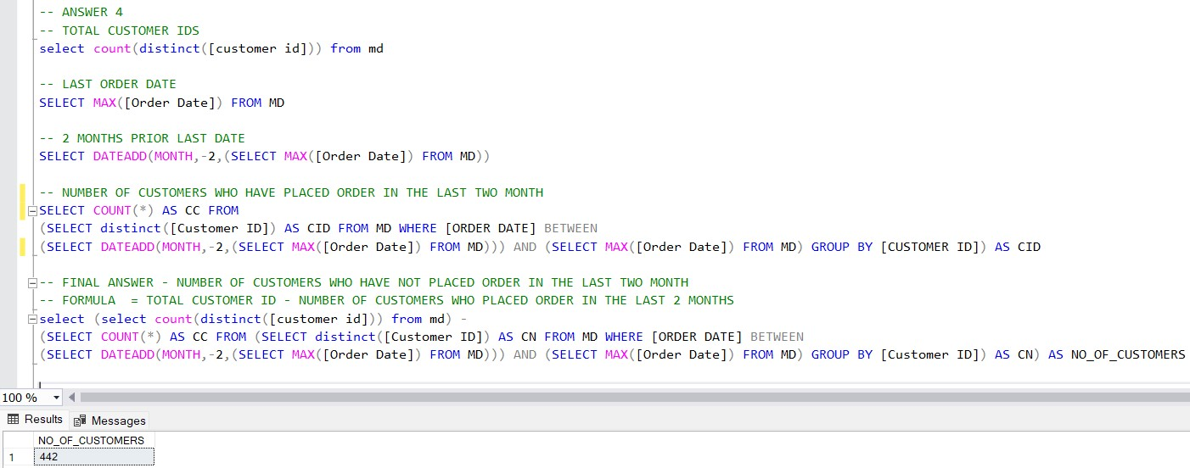

QUESTION 5 : FIND ALL THE CUSTOMERS WHO ARE LIVING IN THE SAME CITY.

ANSWER 5 :

1. FIRST WE WILL FIND THE CITY HAVING COUNT OF DISTINCT CUSTOMER ID GREATER THAN 1.

**SELECT CITY FROM CUSTOMERS GROUP BY CITY HAVING COUNT(DISTINCT([CUSTOMER ID])) >1**

1. THEN WE WILL FIND THE ALL THE CUSTOMERS LIVING IN THE SAME CITY.

**SELECT [CUSTOMER ID], [CUSTOMER NAME], CITY FROM CUSTOMERS WHERE CITY IN**

**(SELECT CITY FROM CUSTOMERS GROUP BY CITY HAVING COUNT(DISTINCT([CUSTOMER ID])) >1)**

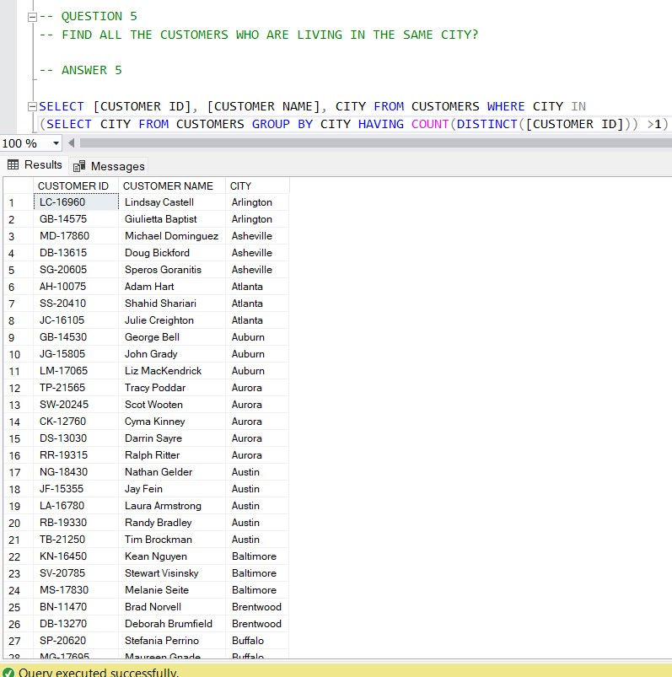

THIS IS NOT THE FULL ANSWER. TOTAL 664 CUSTOMERS.